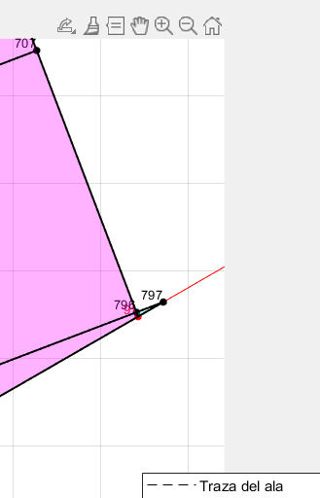
"I aim to establish a clear and standardized documentation framework to ensure accurate interpretation of the information I provide. This documentation will serve two main purposes: first, it will act as a reference guide for me when writing the thesis later, helping maintain consistency and clarity in the presentation of my ideas. Second, it will facilitate effective communication with you, ensuring that the context and intent of the documented information are fully understood without room for misinterpretation." At the last rib, when creating surfaces the triangle that exceed that rib should not be included for obvious reason. See image.
ChatGPT said:
In this case, you need to implement a check that ensures triangles exceeding the last rib are excluded during the surface generation process. The condition should ensure that any surface element (e.g., a triangle) exceeding the defined boundary of the last rib is filtered out.

🚀 Suggested Implementation in MATLAB
Here’s how you can handle this:
1️⃣ Define the Boundary of the Last Rib
Assume the last rib lies at a certain x-coordinate or rib index. Any triangle with vertices that exceed this boundary should be excluded.
matlab
CopyEdit
last_rib_x = max(combined_nodes.x(combined_nodes.rib_index == "last_rib")); % Replace "last_rib" with the actual rib index

2️⃣ Filter Triangles Based on Vertex Positions
When creating the surfaces, check if any of the triangle's vertices exceed the boundary of the last rib. If so, exclude that triangle.
matlab
CopyEdit
% Example tri_surfaces table
% tri_surfaces contains columns: node_1, node_2, node_3 (vertex indices)

% Get coordinates of the triangle vertices
node_coords = combined_nodes(:, {'x', 'y', 'local_id'}); % Node coordinates

% Loop through triangles and check their vertices
valid_triangles = true(height(tri_surfaces), 1); % Initialize validity mask
for i = 1:height(tri_surfaces)
% Get triangle vertices
nodes = tri_surfaces{i, {'node_1', 'node_2', 'node_3'}};
coords = node_coords(ismember(node_coords.local_id, nodes), :);

% Check if any vertex exceeds the last rib boundary
if any(coords.x > last_rib_x)
valid_triangles(i) = false; % Mark as invalid
end
end

% Filter out invalid triangles
tri_surfaces = tri_surfaces(valid_triangles, :);

3️⃣ Optional: Visual Debugging
You can plot the triangles and visually confirm that the ones exceeding the rib are excluded.
matlab
CopyEdit
% Plot triangles
figure;
hold on;

% Plot valid triangles
for i = 1:height(tri_surfaces)
nodes = tri_surfaces{i, {'node_1', 'node_2', 'node_3'}};
coords = node_coords(ismember(node_coords.local_id, nodes), :);
fill(coords.x, coords.y, 'cyan', 'EdgeColor', 'black'); % Valid triangles
end

% Plot the last rib boundary
plot([last_rib_x, last_rib_x], ylim, '--r', 'LineWidth', 1.5); % Last rib line
hold off;

4️⃣ Add Documentation in the Code
Include a reference to the condition for excluding triangles:
matlab
CopyEdit
% 📌 Exclude triangles exceeding the last rib
% Triangles whose vertices have x-coordinates beyond the last rib (x > last_rib_x)
% are excluded during surface generation. See Documentation Section 4.2.1 for details.

